

PQ Social Work - Application Guide 2025/6

This guide will show you the process for starting and submitting your Northumbria University application and the four main steps leading to enrolment on your chosen PQ Social Work of study.

The modules available to study in 2025/6 are:

- Safeguarding Adults SW7000/SW7003 (September 2025)
- Safeguarding Children SW0735/SW0736 (January 2025)
- BIA Best Interests Assessors SW7009 (February 2026)
- Trauma Informed Practice SW7001 (March 2026)
- Mental Capacity Act: Advanced Practice SW7002 (October 2025)
- Practice Education 1 SW7007 (October 2025/April 2026)
- Practice Education 2 SW7008 (October 2025/April 2026)
- Work Based Learning Project SW0738 (October 2025)

The four main steps in completing your application:

STEP 1 – ON-LINE APPLICATION LINK

STEP 2– STARTING AND SUBMITTING YOUR APPLICATION
- STEP 3 – RECEIVING YOUR OFFER
- STEP 4 – ENROLMENT AND UPLOADING YOUR SPONSOR LETTER
- STEP 5 – ADDITIONAL DOCUMENTATION - FOR SW7007 BEST INTEREST ASSESSORS ONLY

STEP 1 – ON-LINE APPLICATION LINK

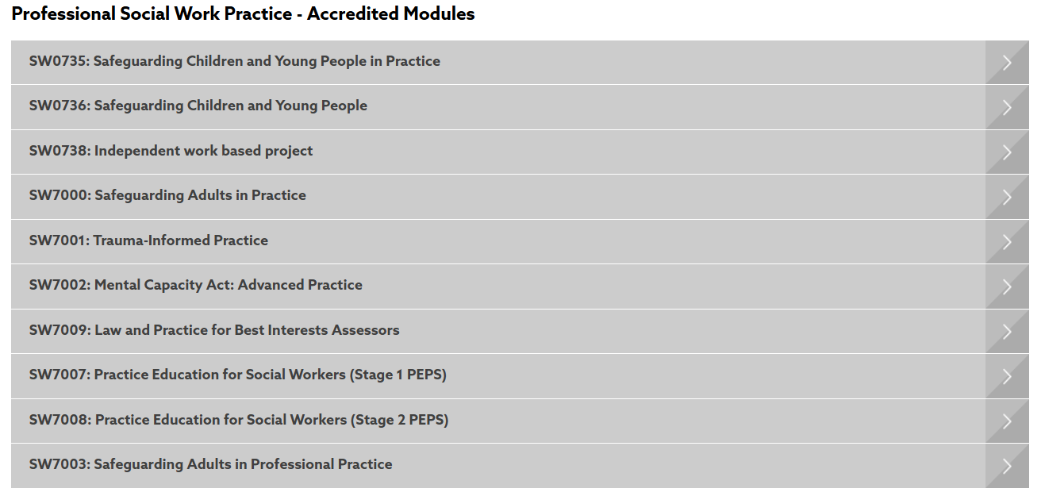
From the main landing page for Postgraduate Certificate - Professional Social Work Practice on the Northumbria University webpage, you can select your chosen module.


Once you have selected your module, select Discover More to go to the individual module webpage. Click on the APPLY NOW button to start your application.

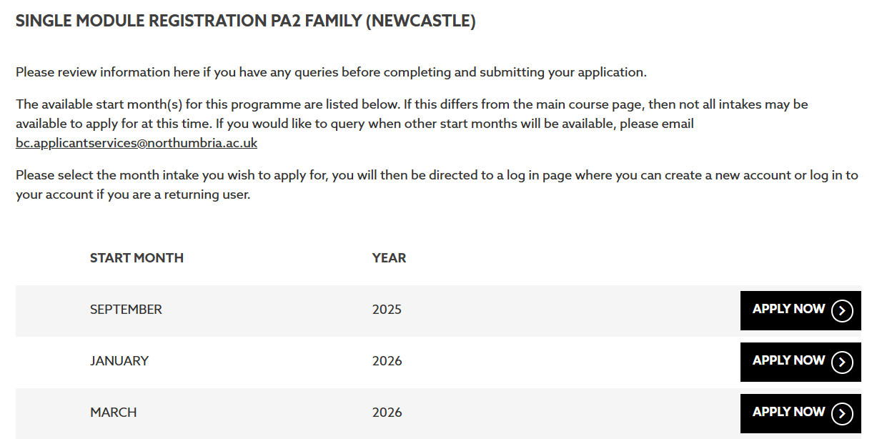
Please select the start month for or closest to the start date of your chosen module, then select APPLY NOW.
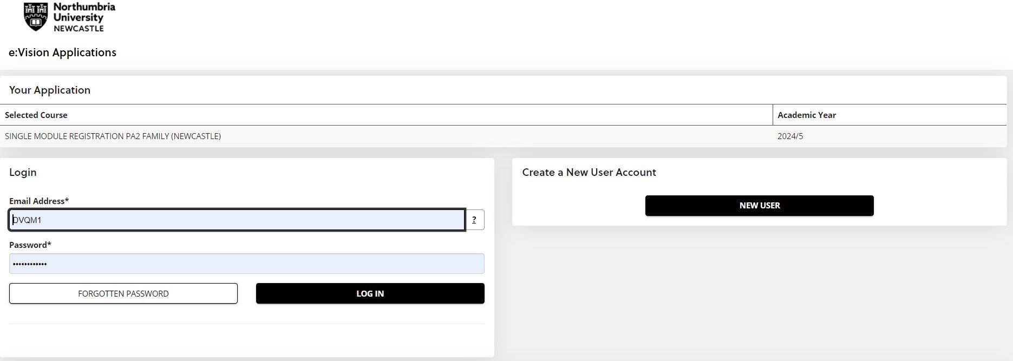
Once you have clicked through the link, you will be able to either create a new account or log in with your previous details (if you have studied with Northumbria University before) to start your application.

STEP 2– STARTING AND SUBMITTING YOUR APPLICATION

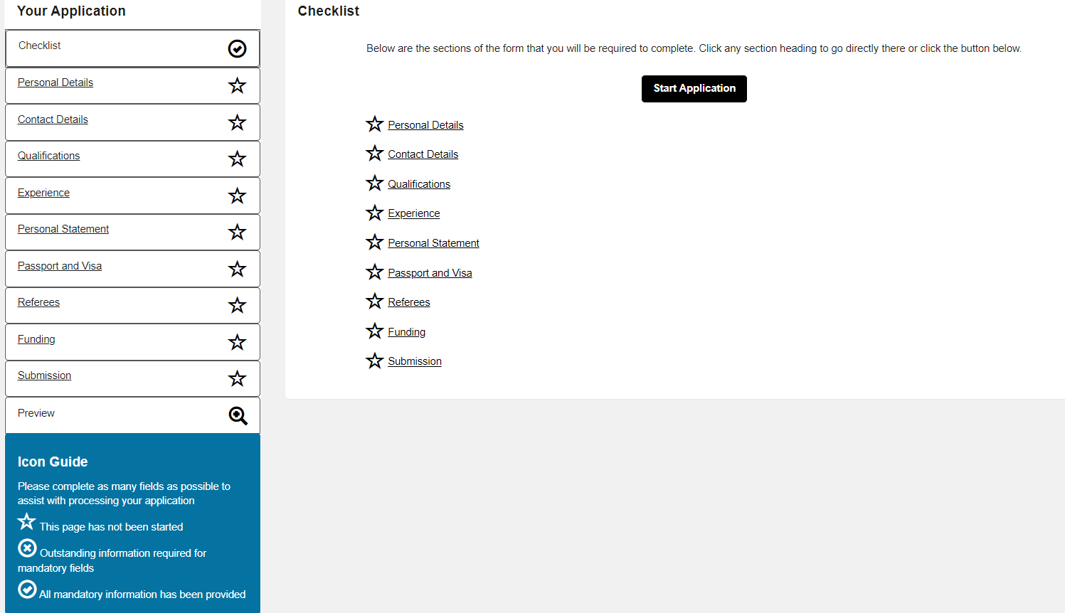
After you have created your account (or logged into your account), you will be able to start completion of the online application form. The checklist below enables you to track which sections of the application form you have completed, and which sections are still to be completed. Some sections of the application form are mandatory, and you will not be able to submit your application until you have completed these sections. You can save and return to your application if you are not able to complete your application form all at once.

You MUST provide:

- Your contact and personal details
- Highest level qualification (e.g. degree – please upload your certificate and/or transcript as evidence)
- Passport/visa if not a UK passport holder
- Confirmation of your module choice – put your module name or code in the Personal Statement field

PLEASE NOTE – FOR MODULE SW7009 BEST INTEREST ASSESSORS, FURTHER INFORMATION IS REQUIRED DUE TO SOCIAL WORK ENGLAND REGULATIONS. PLEASE TURN TO PAGE 6 FOR MORE INFORMATION.

We would also ask that your provide your current employment details and/or a CV to cover your work experience. For your programme, you do not need to provide references or a full personal statement. If you cannot skip any of these fields, feel free to use ‘N/A’ or nsapplicantservices@northumbria.ac.uk to complete them.

Once you have provided the required information on your online application form, please submit your
application – you will receive an automated email of confirmation once this has been completed.

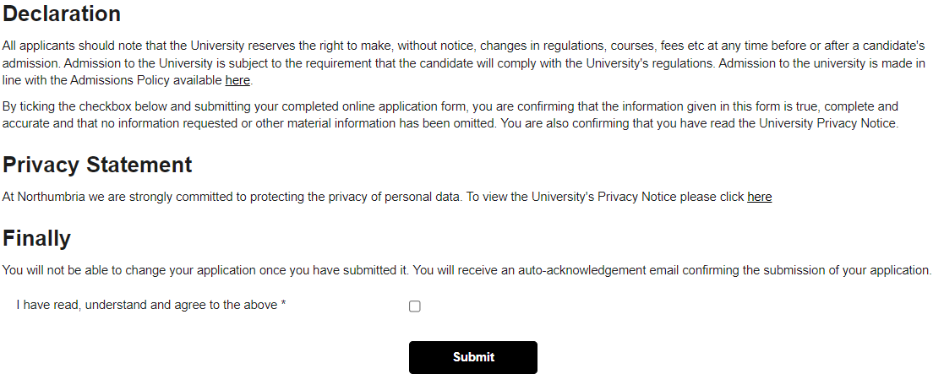
STEP 3 – RECEIVING YOUR OFFER AND ENROLMENT
After you have submitted your application, your application will be reviewed and you will receive confirmation of the decision on your application via email. If all required information has been provided, you should expect to receive your Unconditional Offer within 5 working days. You will be notified via email once you have received your Unconditional Offer.
If any information is missing (e.g. missing qualification evidence or evidence of change of name if qualification is in a different name to your application), you will be contacted via email. The email will detail the information that we require and you can then upload your information via the Applicant Portal. Log in details for you to access your Applicant Portal, will be sent to you in a separate email shortly after you submit your application.
Once you have received your email confirming your place on the Programme, you should then log into your Applicant Portal to accept your offer. You can accept your offer by clicking on the Respond to Offer section. You then choose ‘Accept offer’ via the drop down menu and follow any further instructions you are provided with.
For the PQ Social Work modules, you may find your programme has been changed to Postgraduate Certificate in Professional Social Work Practice at offer stage. This is just a system amendment for applicants who are taking their second module – your chosen module will not be affected or changed.
You will not receive your enrolment instructions to join the programme until you have accepted your offer.
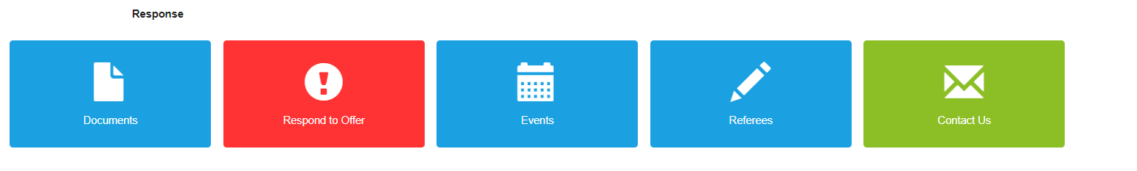
There may be times where the offer that we have made to you is conditional, i.e. we are waiting for a mandatory piece of information from you in order to make you an unconditional offer. In this scenario, you can still accept your conditional offer, but please note that you will be unable to enrol until you have been made an unconditional offer and have then accepted your unconditional offer.

STEP 4 – ENROLMENT AND UPLOADING YOUR SPONSOR LETTER

After you have accepted your Unconditional Offer, you will be eligible to enrol for your course. You should expect to receive your enrolment instructions via e-mail 2 to 3 weeks before the start of your course.
All students need to enrol before they can join their course. You will not be able to access your online teaching materials, Northumbria e-mail or use Northumbria University services until you have completed your enrolment and accepted the institution regulations.

After you have enrolled, you will be able to upload a sponsor letter if you have been sponsored by your employer or agency to undertake your module.

This must be on the official letterhead of the organisation that is sponsoring you and must be signed by someone other than yourself. Please make sure the letterhead includes the company address, email address and telephone number for payments.

Please make sure the following information is included in the letter, otherwise this will cause delays in processing:
- Student name and number
- The amount or the percentage of the sponsorship
- The academic year/years the sponsorship applies to
- Purchase order number. If no purchase order number is required confirmation will be required via email to fi.creditcontrol@northumbria.ac.uk
- Accounts payable contact name, telephone number and email address (where invoices should be sent)
- Any other reference that the sponsor would like to be quoted by the University when we request payment.
- A VAT registration number if the company has one. If not, this must be stated in the letter.

This letter should be sent to the University following the instructions below. Please note you will only be able to submit your sponsor letter once you have enrolled onto your programme.
- Go to https://myportal.northumbria.ac.uk/Help-and-support/Money-and-Finance/Make-a-Payment/Payment-of-fees-by-a-sponsor
- Type Sponsor Letter the text box under Still need help with Payment of fees by a sponsor? And click Send.
- Click on the My Enquiries button at the top of the webpage.
- Click on the enquiry you have just submitted.
- Select Attach File
- Select the relevant file in your personal folders and click Open.
- Click Send
- A message will appear to confirm that the attachment has been sent.
- Click the X button in the top right corner to close the screen.
- Your enquiry should now display an attachment.

All information regarding the sponsor letter requirements can be found on our website.

If you have any queries relating to your application, or would like further information, then please do not hesitate to contact Applicant Services at nsapplicantservices@northumbria.ac.uk or on 0191 406 0901. For problems with your Northumbria University account (e.g. unable to log into your account), you can also contact IT Services at www.northumbria.ac.uk/itchat or on 0191 227 4242.

STEP 5 – ADDITIONAL DOCUMENTATION - FOR SW7009 BEST INTEREST ASSESSORS ONLY

In order to meet statutory and regulatory body requirements, SW7009 Law and Practice for Best Interest Assessors requires additional information to be provided at application stage. These can be provided either within your application or after it has been submitted, however all of the required information must be provided before you can receive an offer of a place on the course.

You will need to provide:

- Your qualifying degree certificate or equivalent qualification
- Provide your professional registration number in the Professional Memberships section of the application form
- Complete the work experience section of your application form, demonstrating a minimum of two years post qualified practice experience by the start of the module in February 2026
- Either a personal statement of no more than 1,000 words explaining why you believe your knowledge, experience and values will enable you to uphold the rights of people who may be deprived of their liberty, OR
evidence of successful completion of Northumbria University modules SW0735/SW0736, SW7000/SW7003 or SW7002. We cannot accept evidence of equivalent modules undertaken at other institutions.
- Your proposed arrangements for a BIA Practice Assessor and practice observation opportunities – please see Appendix 2 of the SW7009 Application Information
- An enhanced Disclosure and Barring Service check – our DBS team will contact you after you have submitted your application to arrange this.

To provide any of the supporting documentation listed above or for any further questions regarding your application, please contact us at nsapplicantservices@northumbria.ac.uk. If any of the above is missing from your application at the point of submission, you will be contacted via your Applicant Portal to follow up. Submitting an application does not guarantee the offer of a place on the course.

