Human Resources Subject Challenge

Addressing Inequality and the “New Normal”

Following the covid-19 pandemic, global workforce expectations have shifted including increased pressure for organisations to provide flexibility and hybrid working as well as concerns around well-being and meaningful work. Pre-pandemic ideas about the “future of work”, which were focussed on robots and artificial intelligence, now seem less important when compared to these practical changes prompted by large-scale working from home during the pandemic. The pandemic provided a welcome focus on people issues, from the appreciation given to previously under-valued front-line workers (think the NHS, supermarket workers), to the negative exposure of organisations who mistreat their workers (think Wetherspoons). However, many inequalities such as those related to race, gender, mental health, poverty and skills widened during lockdowns and beyond (see figures 1 and 2). These need to be taken into account by human resources professionals as they determine what key functions like talent management, development, leadership and recruitment will look like going forward.



Figure 1: The government was criticised for not considering gender equality in its post-pandemic recovery plan. Women were more likely than men to be furloughed or made redundant and do a greater share of unpaid care work.

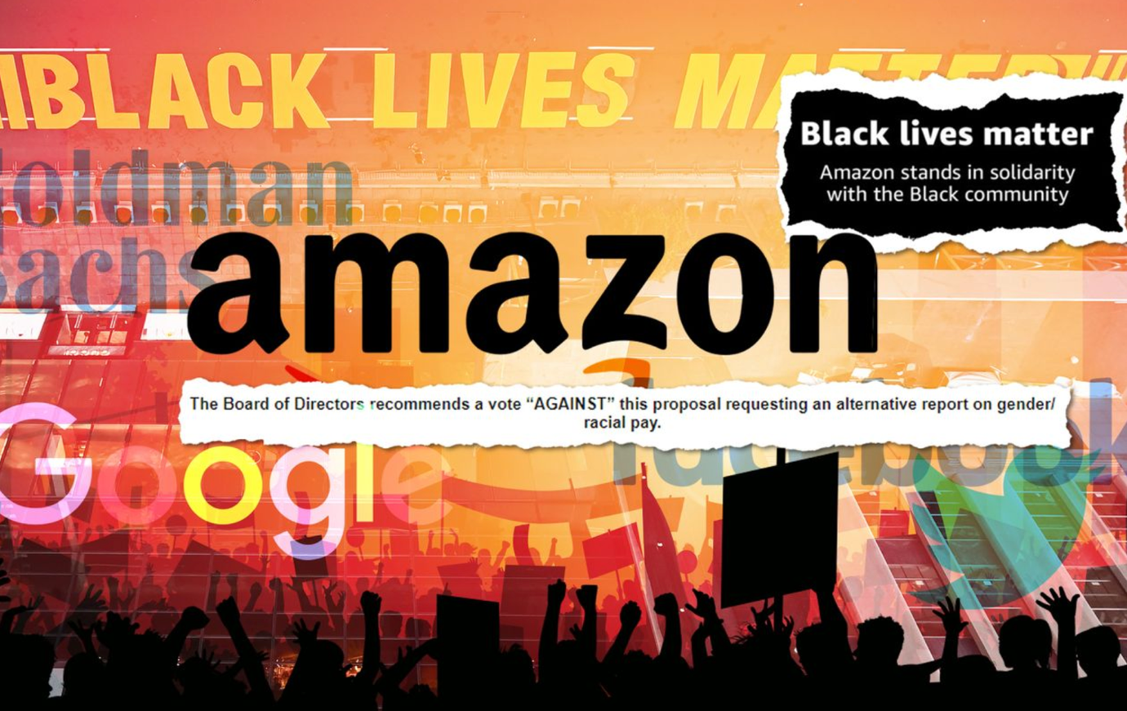

Figure 2: Organisations are being pushed to demonstrate that their actions back up their stated commitment to Black Lives Matter. Understanding Society found that BAME workers were more likely to have lost their jobs than be furloughed during lockdown.

Your Task

Design a poster (you can use Canva, Powerpoint, Prezi or other software of your choice) around the “future of work”, focussing on:
- How you think ‘work’ will look different after the pandemic, compared to before
- How you think these changes will address inequalities worsened by the pandemic
- Any examples you can find of companies that have made positive changes

You may wish to focus on one issue and/or group facing inequalities rather than try to cover everything.

How to Submit

Please submit your completed poster via email to Helen Tracey (helen.tracey@northumbria.ac.uk) by midnight on 18 September 2023. There will be prizes awarded at Induction week for the best entries!

