The Future of Evaluation in Health & Social Care:

Symposium Speakers’ and More than Minutes’ Profiles



Newcastle Business School

14/01/2025 – 16/01/2025

Professor Dave Byrne

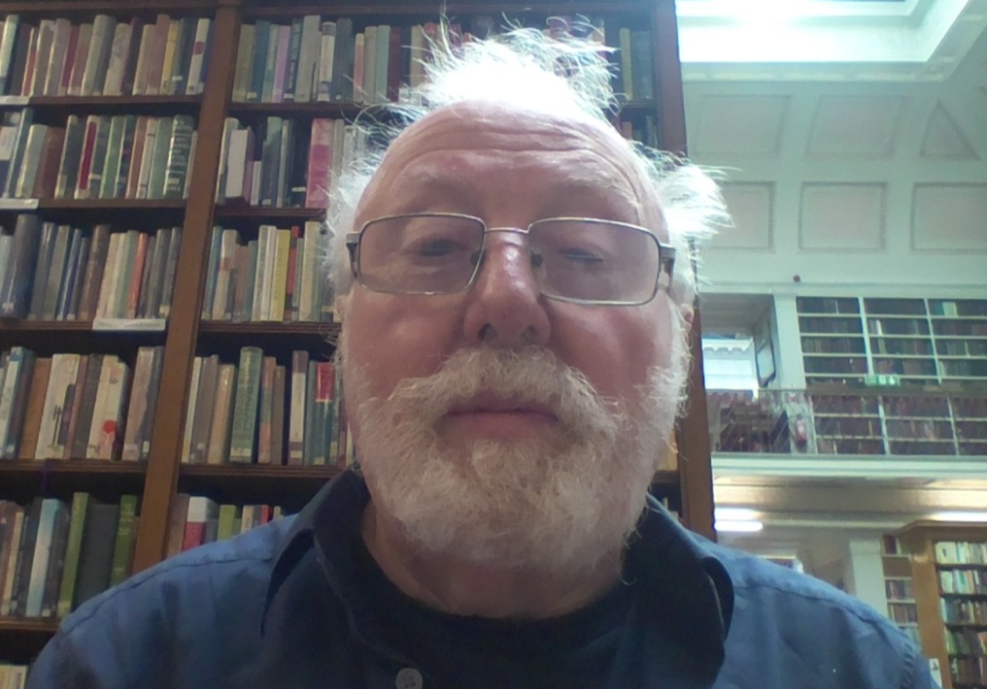

Title of Presentation:

“Understanding causes and effects as system states: the implications for evaluation.”

Biography:

David Byrne retired as Professor of Sociology at Durham University. His career has been at the interface of Sociology and Social Policy with the emphasis on action research as a method and inequality as a focus. Books include Social Exclusion (2005), Applying Social Science (2011), Complexity Theory – the state of the art (2013) (with Callaghan – second edition 2023), and works on Paying for the Welfare State in the 21st Century (with Ruane 2017), Inequality in a Context of Climate Crisis after COVID (2021) and Class after Industry (2019). All his work is defined by a complexity realist methodology. A lot of recent work has been around evaluation including involvement in CECAN and K4U Knowledge for Use. Together with Callaghan and Uprichard he has just completed a book on Researching Complex Crises: Complexity informed research for social transformation for Policy Press and is now engaging with the development of scenarios as part of an action research programme.

Professor Tracy Finch

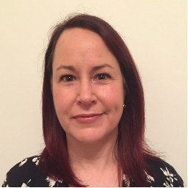

Title of Presentation:

‘What are we evaluating when we do process evaluations?’

Biography:

I am Professor of Implementation Science and Healthcare at Northumbria University, and an implementation scientist with a background in health psychology spanning a 25+ doctoral career in applied health and social care research. My internationally recognised profile of research is on complex health and care interventions, qualitative process evaluation, and implementation science. I co-developed Normalisation Process Theory (NPT), which explains mechanisms through which new health and care practices are implemented, embedded and integrated into services. I lead on developing practical tools to facilitate implementation processes (ItFits-toolkit), and measures of implementation outcomes (NoMAD). These inform my work within clinical trial research, and other intervention and implementation studies.

Professor Mike Kelly
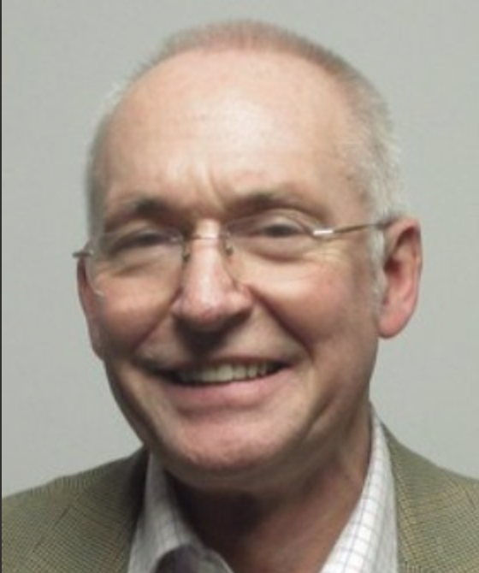

Title of Presentation:

“Why is Changing Health Inequalities So Difficult?”

Biography:

Professor Mike Kelly is Senior Visiting Fellow in the Department of Public Health and Primary Care at the University of Cambridge. Between 2005 and 2014 he was the Director of the Centre for Public Health at NICE, where he led the teams producing public health guidelines. He has advised the House of Commons Health Select Committee and been a witness before parliamentary committees on a number of occasions. He has chaired committees for MRC, ESRC, the Foods Standards Agency, PHE and OHID. From 2005 to 2007 he directed the methodology work stream for the World Health Organisation’s (WHO) Commission on the Social Determinants of Health. He has a continuing interest in health inequalities and is pursuing a programme of research in Cambridge on this topic. His other research interests include the methods and philosophy of evidence-based medicine, prevention of heart disease, health related behaviour change, the causes of non-communicable disease, end of life care, dental public health, transport and health, and the sociology of chronic illness.

Professor Carl May
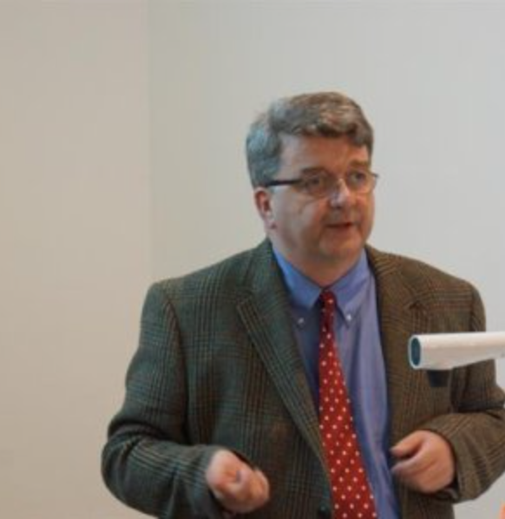

Title of Presentation:

‘What are we evaluating when we do process evaluations?’

Biography:

I am a behavioural scientist and implementation scientist with a wide range of research interests across the sociology of health technologies and of human relations In the healthcare systems of both high and low/middle income countries. This work has ranged from very applied evaluation studies in health services research (especially in qualitative studies nested within randomized controlled trials) through studies of the social construction of professional-patient relations and different disease entities, to fundamental social science research on the dynamics of human agency under conditions of constraint.

Sian McArthur & Chris Murray
(More than Minutes)
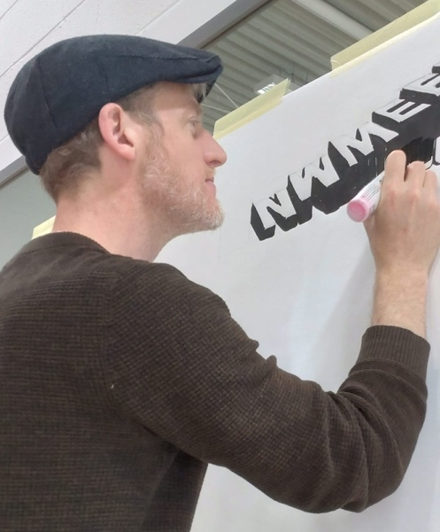
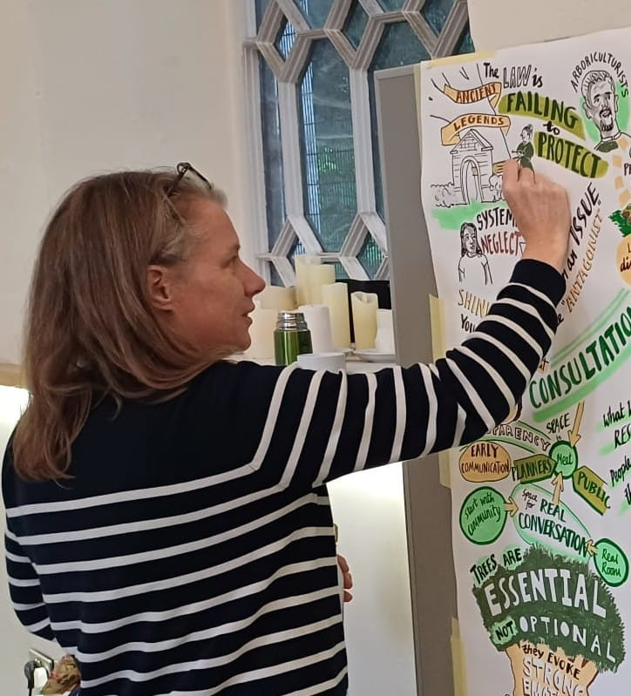

Biography:

Both Chris and I have been working as freelance visual minute artists with More Than Minutes for over ten years. We have worked with many different clients and at a variety of types of events, we work with local community groups, illustrate research projects, go to important and inspirational conferences will small and large organisations, as well as schools and National companies. At these meetings and conferences, we listen for the key themes, ideas and phrases and use them to create a visual record of the event, a rich picture that is a reminder of the day, a way to start conversations and share the information in a digestible way.
Chris and I also animators, we have both done explainer videos and live animations at conferences, Chris has also worked on music videos.

Dr. Rachel Meacock


Title of Presentation:

“Reconciling the micro and macro impacts of health and care interventions”.

Biography:

Rachel is a Reader in Health Economics at The University of Manchester. Her work focuses on the evaluation of changes to the way that healthcare is financed, organised and delivered. She co-leads one of three new NIHR national reactive evaluation teams and is the joint head of the UK Association for Health Economists, HESG.

Professor Laurence Moore

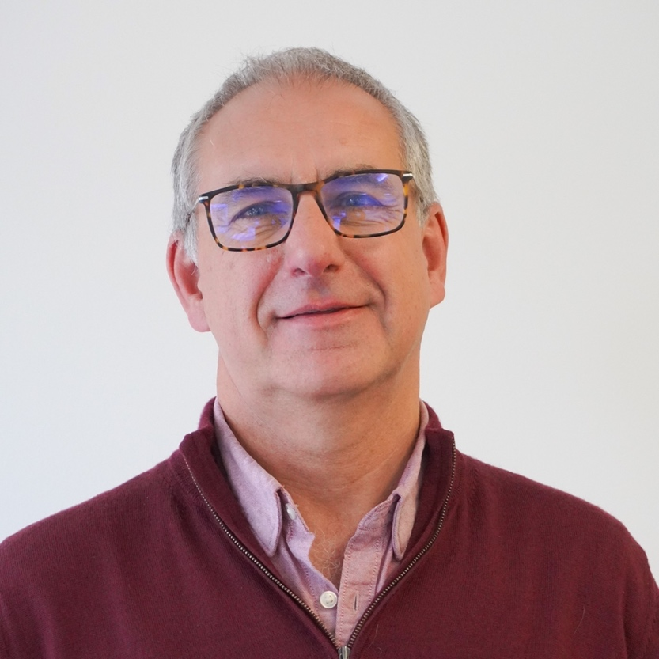

Title of Presentation:

“Strength through diversity?”

Biography:
Professor Laurence Moore is Director of the MRC/CSO Social and Public Health Sciences Unit. He is a social scientist and statistician with a track record in the development and evaluation of interventions to improve population health. Working in multidisciplinary teams and in collaboration with policy makers, practitioners and the public, he has completed mixed methods evaluations of diverse interventions and programmes, which have then had a direct impact on policy and practice. These include evaluations of peer influence based interventions including ASSIST (smoking) and STASH (sexual health), exercise referral schemes, fruit tuck shops, the free school breakfast initiative in Wales and smoking cessation in pregnancy. He was senior author of the 2021 update of the MRC/NIHR Framework for the development and evaluation of complex interventions. Laurence is increasingly interested in the application of complex systems concepts and methods to population health intervention research. He is academic lead of the new NIHR Health Determinants Research Collaboration Glasgow.
Professor Ray Pawson
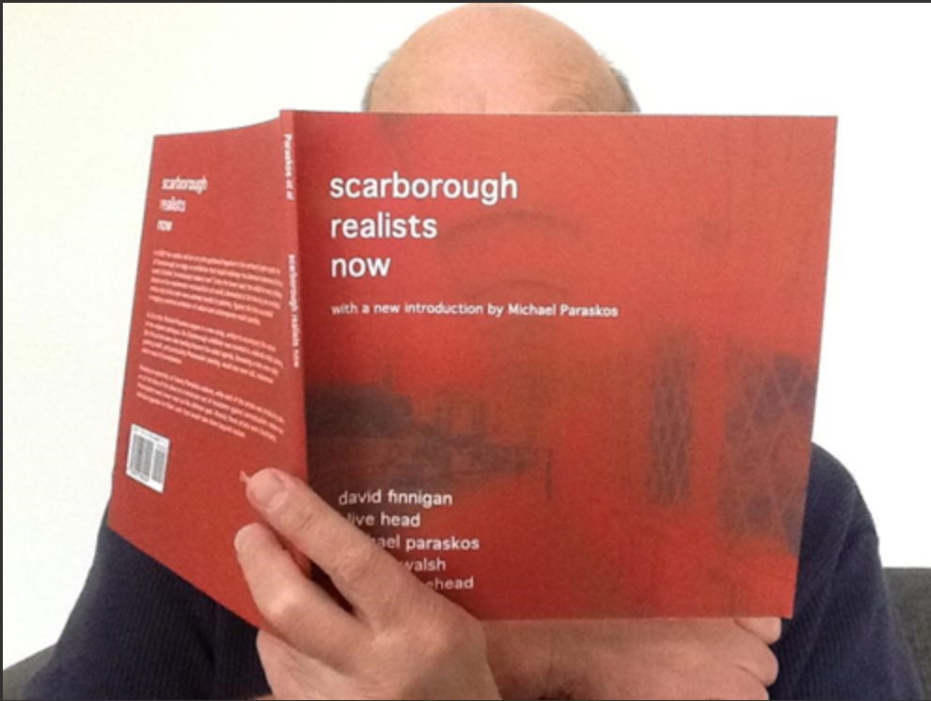

Title of Presentation:

“Farewell to Evaluation”

Biography:

Ray Pawson is a methodologist, working across the social sciences. Publications include five books: A Measure for Measures (1989), Realistic Evaluation (1997 with Nick Tilley), Evidence-Based Policy: A Realist Perspective (2006), The Science of Evaluation: A Realist Manifesto (2013), and the grand summation, How to Think Like a Realist: A Methodology for Social Science (2024). His work has had particular resonance in the field of policy and programme evaluation. Much to his surprise, his ‘realist method’ has become a standard component of the applied research repertoire.

Dr. Kathryn Skivington
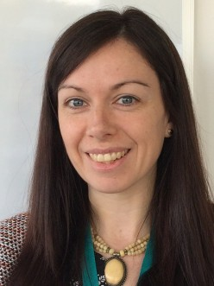

Title of Presentation:

“Strength through diversity?”

Biography:

Kathryn Skivington is an honorary research fellow at the University of Glasgow and public health advisor at Public Health Scotland. She was the lead author of the 2021 MRC/NIHR Framework for Developing and Evaluating Complex Interventions, which was developed by a group of experts from different health-related fields. Kathryn has been involved in numerous public health interventions, aiming to address social determinants of health, and has an interest in methods for developing interventions as well as evaluation. She is currently working within the Scottish Prevention Hub, which is a collaboration between Public Health Scotland, Police Scotland and Edinburgh Futures Institute. She is largely working on a school/community-based intervention to support the use and understanding of routine administrative and experiential data to collaboratively assess and prioritise action for positive change for children and young people, while grappling with issues related to evaluation and learning, and models for the approach to have wider reach and sustainability.

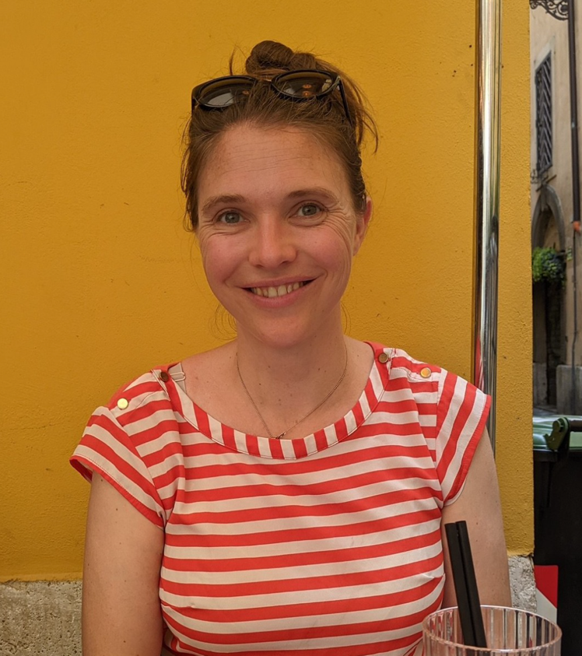
Dr. Emily Warren

Title of Presentation:

“Are realist RCTs possible? Reflections from the INCLUSIVE trial”

Biography:

“Emily Warren is an Assistant Professor at the London School of Hygiene & Tropical Medicine, where she uses realist approaches to evaluate social and health care policies and complex social interventions. Her research was awarded the European Society for Prevention Research Presidents’ Award in recognition of her research on the philosophical cogence and feasibility of realist RCTs.”

